
National Textile University
Department of Computer Science

Subject: Operating System

Submitted to: Nasir Mehmood

Submitted by: Asbah Asif

Reg number:23-NTU-CS-1141

Semester:5th

Task 1 –
Thread Information Display Write a program that creates 5 threads. Each thread should:
• Print its thread ID using `pthread_self()`.
• Display its thread number (1st, 2nd, etc.).
• Sleep for a random time between 1–3 seconds.
• Print a completion message before exiting.
Expected Output: Threads complete in different orders due to random sleep times.

Code:
#include <stdio.h>
#include <stdlib.h>
#include <pthread.h>
#include <unistd.h>
#include <time.h>

#define NUM_THREADS 5
void* thread_function(void* arg) {
int thread_num = *((int*)arg);
pthread_t tid = pthread_self(); // get thread ID
int sleep_time = rand() % 3 + 1;
printf("Thread %d started | Thread ID: %lu | Sleeping for %d seconds...\n",
thread_num, tid, sleep_time);
sleep(sleep_time); // sleep for random time
printf("Thread %d (ID: %lu) has completed its work.\n", thread_num, tid);
pthread_exit(NULL);
}
int main() {
pthread_t threads[NUM_THREADS];
int thread_nums[NUM_THREADS];
srand(time(NULL)); // seed random number generator
printf("Creating %d threads...\n\n", NUM_THREADS);
// Create threads
for (int i = 0; i < NUM_THREADS; i++) {
thread_nums[i] = i + 1;
if (pthread_create(&threads[i], NULL, thread_function, &thread_nums[i]) != 0) {
perror("Error creating thread");
exit(1);
}
}
// Wait for all threads to finish
for (int i = 0; i < NUM_THREADS; i++) {
pthread_join(threads[i], NULL);
}
printf("\nAll threads have completed.\n");
return 0;
}
Output:
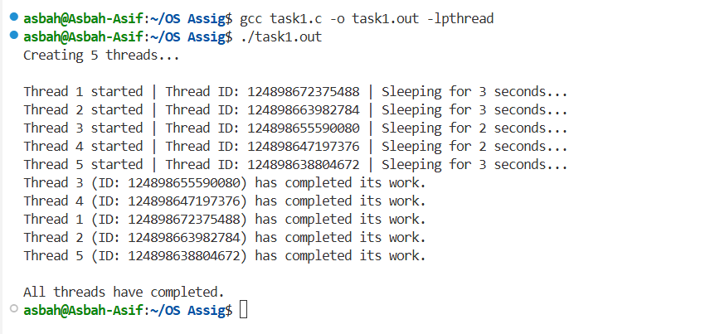

Task:2
Code:
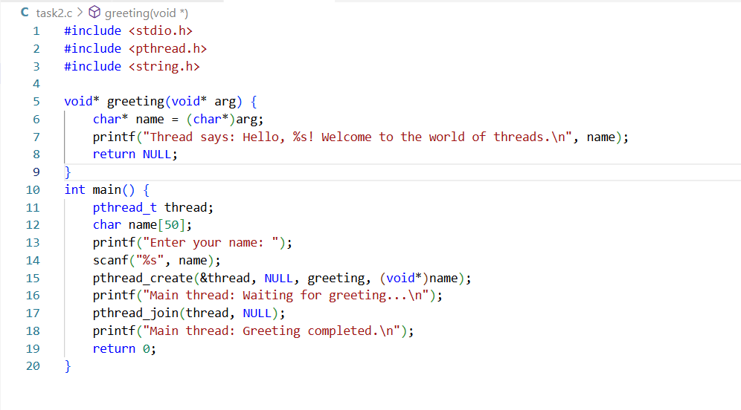
Output:
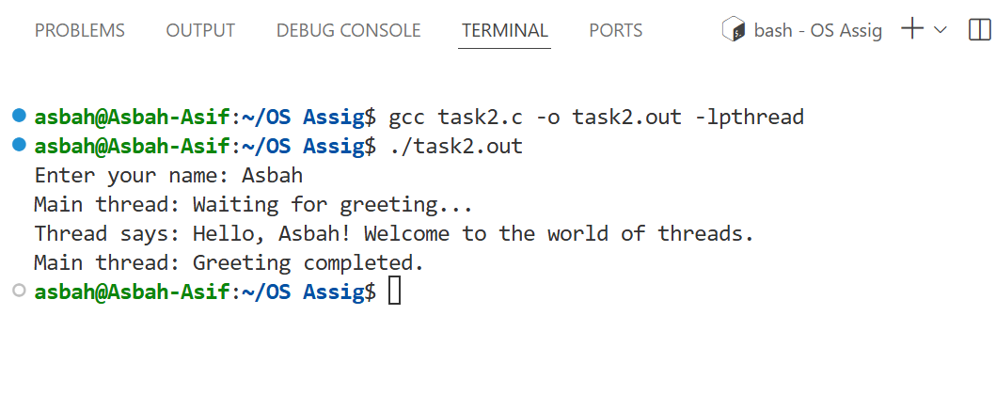

Task:3
Code:

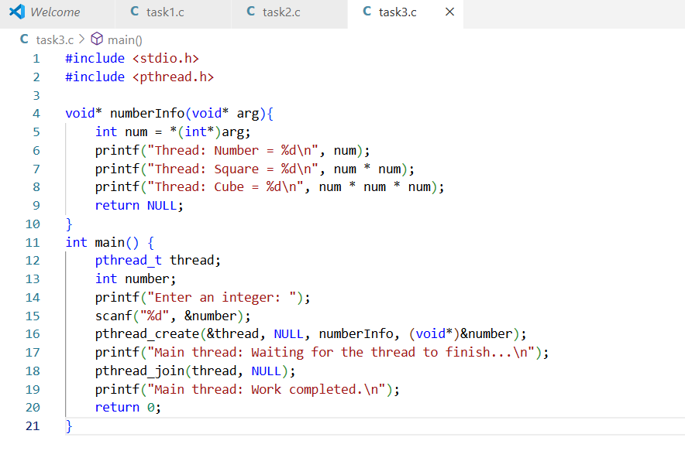
Output:
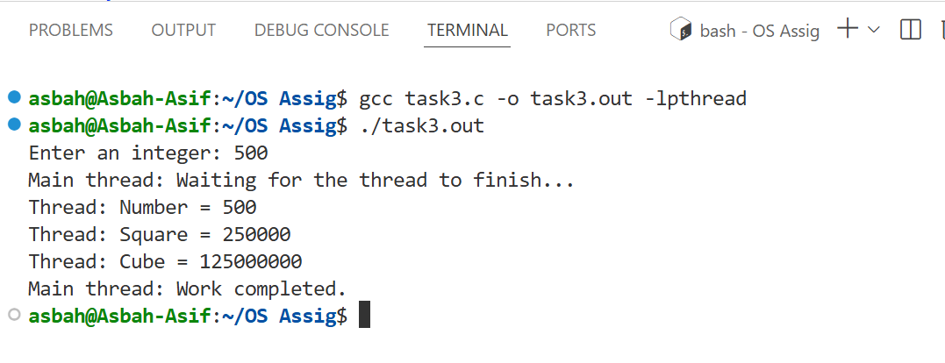

Task: 4
Code:
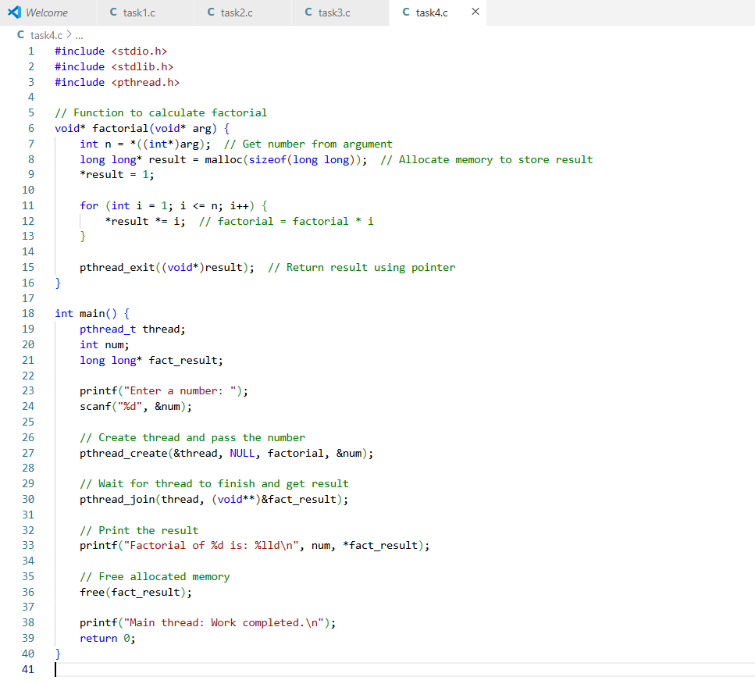
Output:
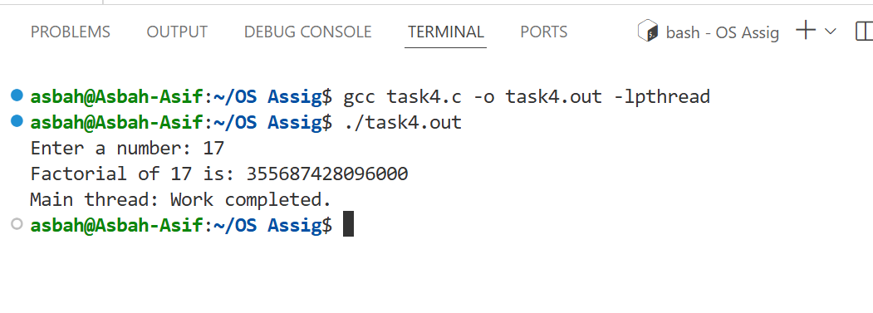

Task: 5
Code:
#include <stdio.h>
#include <pthread.h>
typedef struct {
int student_id;
char name[50];
float gpa;
} Student;
int dean_count = 0; // Shared variable
// Thread function
void* check_dean(void* arg) {
Student* s = (Student*)arg;
printf("\nStudent ID: %d\nName: %s\nGPA: %.2f\n", s->student_id, s->name, s->gpa);
if (s->gpa >= 3.5) {
printf("%s made the Dean's List!\n", s->name);
dean_count++;
} else {
printf("%s did not make the Dean's List.\n", s->name);
}
return NULL;
}
int main() {
pthread_t t1, t2, t3;
Student s1 = {101, "Alice", 3.8};
Student s2 = {102, "Bob", 3.2};
Student s3 = {103, "Charlie", 3.9};
pthread_create(&t1, NULL, check_dean, &s1);
pthread_create(&t2, NULL, check_dean, &s2);
pthread_create(&t3, NULL, check_dean, &s3);

// Wait for threads to finish
pthread_join(t1, NULL);
pthread_join(t2, NULL);
pthread_join(t3, NULL);

// Final result
printf("\nTotal students on Dean's List: %d\n", dean_count);

return 0;
}

Output:
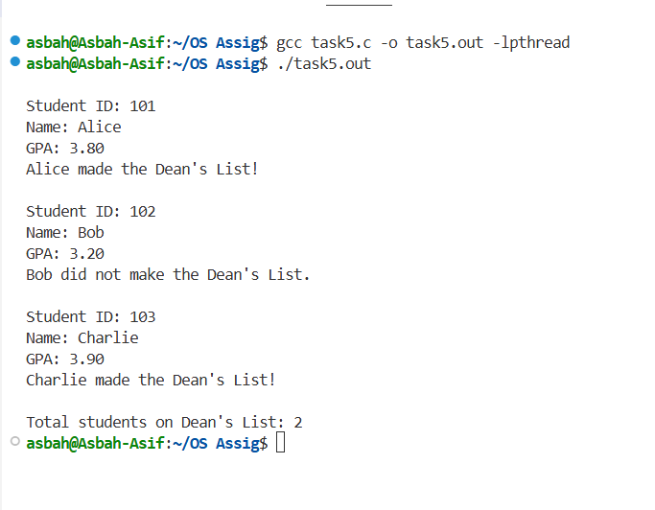

Section-B: Short Questions
Q#1-Define an Operating System in a single line?
Answer:
Operating System (OS):
An Operating System (OS) is system software that manages computer hardware, software resources, and provides services for computer programs.

Q#2- What is the primary function of the CPU scheduler?
Answer:
The primary function of the CPU scheduler is to decide which process from the ready queue should be assigned to the CPU next, to maximize CPU utilization, ensure fairness, and improve overall system performance.

Q#3- List any three states of a process?
Answer:
Three states of a process are:
- Ready: The process is waiting to be assigned to the CPU.
- Running: The process is currently being executed by the CPU.
- Blocked (or waiting): The process is waiting for some event or I/O operation to complete.

Q#4- What is meant by a Process Control Block (PCB)?
Answer:
A Process Control Block (PCB) is a data structure in the operating system that contains important information about a specific process, such as its process ID, state, CPU registers, memory management information, and scheduling details.

Q#5- Differentiate between a process and a program.
Answer:
The difference between a process and a program is
Aspect | Program | Process
Definition | A program is a set of instructions written to perform a specific task. | A process is a program in execution (an active instance of a program).
State | It is passive, stored on disk. | It is active, loaded into memory and being executed.
Resources | Does not require resources like CPU or memory. | Requires resources such as CPU time, memory, and I/O devices.
Example | chrome.exe stored on disk. | A running instance of Chrome browsing a website.

Q# 6- What do you understand by context switching?
Answer:
Context switching is the process of saving the state of a currently running process and restoring the state of another process so that the CPU can switch from executing one process to another.

Q#7- Define CPU utilization and throughput.
Answer:
CPU Utilization:
It is the percentage of time the CPU is actively executing processes rather than being idle.
Throughput:
It is the number of processes completed by the CPU in a given amount of time.

8. What is the turnaround time of a process?
Turnaround time is the total amount of time taken by a process from the moment it enters the system (arrives) until it finishes execution. It measures how long the process takes to complete.
Formula:
Turnaround Time = Completion Time – Arrival Time
9. How is waiting time calculated in process scheduling?
Waiting time is the total time a process spends waiting in the ready queue before getting CPU time for execution. It shows how long the process had to wait to start running.
Formula:
Waiting Time = Turnaround Time – Burst Time
10. Define response time in CPU scheduling.
Response time is the time between the process arrival and the first time it gets the CPU.
It indicates how quickly the system starts responding to a process.
Formula:
Response Time = Time of First CPU Response – Arrival Time

11. What is preemptive scheduling?
Preemptive scheduling allows the operating system to interrupt or stop a currently running process so that a higher-priority or shorter process can use the CPU. This helps improve responsiveness and ensures that important processes are not delayed.
Example: Round Robin, Preemptive Priority, and SRTF are preemptive algorithms.
3

12. What is non-preemptive scheduling?
In non-preemptive scheduling, once a process starts execution, it cannot be stopped until it finishes or voluntarily gives up the CPU. The CPU remains with the same process until it is complete.
Example: FCFS (First Come First Serve) and Non-preemptive SJF.

13. State any two advantages of the Round Robin scheduling algorithm.
- Fairness: Every process gets an equal share of CPU time using a fixed time quantum.
- Good response time: It is suitable for time-sharing systems, making it responsive for interactive users. It prevents starvation since all processes get a turn.
14. Mention one major drawback of the Shortest Job First (SJF) algorithm.
A main drawback of SJF is starvation i.e. longer processes may be continuously delayed if short processes keep arriving and it requires knowledge of burst time in advance, which is often not known.

15. Define CPU idle time.
CPU idle time is the period when the CPU is not executing any process — it remains idle because there are no processes ready to run. It represents wasted CPU time that reduces overall efficiency.
Example: This can happen when all processes are waiting for I/O operations to be completed.

16. State two common goals of CPU scheduling algorithms.
- Maximize CPU utilization: Keep the CPU as busy as possible — avoid idle time.
- Minimize waiting and turnaround time: So, processes complete faster and the system stays efficient. Other goals include fairness, high throughput, and quick response time.

17. List two possible reasons for process termination.
- Normal completion: The process finishes its task successfully and calls exit ().
- Error or interruption: The process is terminated due to errors (like invalid memory access) or by another process e.g., the parent kills it.
Other reasons: time limit exceeded, user request, or lack of resources.

18. Explain the purpose of the wait () and exit () system calls.
- Exit () → Called by a process when it completes; it releases all resources and ends the process.
- Wait () → Used by a parent process to wait for its child process to finish before continuing.
Example: In UNIX, the parent calls wait () after creating a child using fork ().

19. Differentiate between shared memory and message-passing models of inter-process communication (IPC).
Feature | Shared Memory | Message Passing
Communication Method | Processes share a common memory region. | Processes exchange messages through OS.
Speed | Faster as it directs access to memory. | Slower as it involves kernel for every message.
Synchronization | Must be handled by processes e.g., using semaphores. | OS handles synchronization.
Example | Used in databases or multimedia systems. | Used in distributed systems or microservices.

20. Differentiate between a thread and a process.
Aspect | Process | Thread
Definition | Independent program in execution. | A lightweight sub-unit of a process.
Memory | It has its own memory space. | Shares memory with other threads in the same process.
Creation Time | Slower to create. | Faster to create.
Communication | Inter-process communication needed. | Easier as threads share data directly.
Example: A browser (process) has multiple tabs (threads).

21. Define multithreading.
Multithreading is the ability of a CPU or program to execute multiple threads concurrently within a single process. Each thread performs a different task but shares the same resources as memory.
Example:
In a web browser one thread loads a page, another handles user input, another plays audio.

22. Explain the difference between a CPU-bound process and an I/O-bound process.
Type | CPU-bound Process | I/O-bound Process
Definition | Spends most time using CPU for computation. | Spends most time waiting for I/O operations.
Example | Data encryption, calculations, simulations. | File reading, database access, user input.
Performance Goal | Needs faster CPU. | Needs faster I/O devices.

23. What are the main responsibilities of the dispatcher?
The dispatcher is part of the CPU scheduler that handles the actual process switch.
It:
- Performs context switching means it saves the old process state and loads the new one.
- Switches to user mode from kernel mode.
- Jumps to the correct instruction to start or resume the process. Dispatcher speed affects CPU efficiency; faster switching means less overhead.

24. What are the main responsibilities of the dispatcher?
Answer:
The dispatcher is responsible for:
- Switching the CPU from one process to another.
- Performing context switching.
- Switching to user mode.
- Jumping to the proper instruction in the user program to restart it.

25. Define starvation and aging in process scheduling.
Answer
Starvation: When a process waits indefinitely because it never gets CPU time.
Aging: A technique to prevent starvation by gradually increasing the priority of waiting processes over time.

26. What is a time quantum (or time slice)?
Answer:
A time quantum is the fixed amount of time that a process is allowed to run before being preempted in Round Robin scheduling.

27. What happens when the time quantum is too large or too small?
Answer:
Too Large: System behaves like FCFS (poor response time).
Too Small: Too many context switches, increasing overhead.

28. Define the turnaround ratio (TR/TS).
Answer:
Turnaround Ratio=Service Time (TS) / Turnaround Time (TR)​
It measures how efficiently CPU time is used — the smaller the ratio, the better the performance.

29. What is the purpose of a ready queue?
Answer:
The ready queue holds all processes that are:
- In main memory, and
- Waiting to be assigned to the CPU for execution.

30. Differentiate between a CPU burst and an I/O burst.
Answer:
CPU Burst: Period when a process is executing instructions on the CPU.
I/O Burst: Period when a process is waiting for I/O operations to complete.

31. Which scheduling algorithm is starvation-free, and why?
Answer:
Round Robin (RR) is starvation-free because each process gets an equal share of CPU time in cyclic order.

32. Outline the main steps involved in process creation in UNIX.
Answer:
Fork () → Creates a child process (copy of parent).
Exec () → Replaces child’s memory with a new program.
Wait () → Parent waits for child to finish.
Exit () → Child terminates and returns status to parent.

33. Define zombie and orphan processes.
Answer:
Zombie-Process:
A zombie process is a process that has completed execution but still has an entry in the process table because its parent has not yet read its exit status using wait ().
- State: Terminated but not yet removed.
- Example: A child finishes execution but the parent hasn’t called wait ().
Orphan-Process:
An orphan process is a process whose parent has terminated before the child process completes.
- The orphan is automatically adopted by the init (PID 1) process, which later performs the wait () call to clean it up.

34. Differentiate between Priority Scheduling and Shortest Job First (SJF).
Answer:
Aspect | Priority Scheduling | Shortest Job First (SJF)
Basis of Selection | Process with the highest priority executes first. | Process with the shortest burst time executes first.
Priority Criteria | Based on user or system-defined priority levels. | Based on CPU burst length (shorter → higher priority).
Starvation | High chance of starvation for low-priority processes. | May cause starvation for long processes.
Type | Can be pre-emptive or non-pre-emptive. | Can also be pre-emptive (Shortest Remaining Time First) or non-pre-emptive.
Goal | Execute important tasks first. | Minimize average waiting and turnaround time.

35. Define context switch time and explain why it is considered overhead.
Answer:
Definition:
Context switch time is the time taken by the CPU to save the state of the current process and load the state of the next process during process switching.
Why it’s considered overhead:
- During a context switch, the CPU is not executing any useful user process—it’s only performing administrative tasks (saving/loading registers, updating PCB, etc.).
- Hence, it consumes CPU time but does not produce any productive work, making it an overhead in the system.

36. List and briefly describe the three levels of schedulers in an Operating System.
Answer:

Scheduler | Function | Description
1. Long-Term Scheduler (Job Scheduler) | Controls degree of multiprogramming. | Selects which processes should be admitted into the ready queue from the job pool on disk.
2. Short-Term Scheduler (CPU Scheduler) | Allocates CPU to ready processes. | Selects one of the ready processes to execute next. Runs very frequently.
3. Medium-Term Scheduler (Swapper) | Handles swapping between memory and disk. | Temporarily removes processes from main memory (suspension) and reintroduces them later to improve performance.
37. Differentiate between User Mode and Kernel Mode in an Operating System.
Answer:
Aspect | User Mode | Kernel Mode
Access Level | Limited access to system resources. | Full access to hardware and system resources.
Execution Scope | Runs user applications (like browsers, editors, etc.). | Runs OS kernel functions and device drivers.
Privileged Instructions | Cannot execute privileged instructions. | Can execute privileged instructions (e.g., I/O control, memory management).
System Calls | Programs switch to kernel mode using system calls. | Kernel mode executes system calls and returns to user mode.
Protection | Prevents user programs from directly accessing critical hardware. | Used by the OS to manage resources safely.

Section C
1. Describe the complete life cycle of a process with a neat diagram showing transitions between New, Ready, Running, Waiting, and Terminated states.

Process Life Cycle
A process life cycle represents the different states a process goes through during its execution, from creation to termination. The operating system manages these states and transitions to ensure smooth execution and resource utilization.
States of a Process
- New:
The process is being created and initialized by the operating system.
- Ready:
The process is loaded into main memory and waiting to be assigned to the CPU.
- Running:
The process is currently being executed by the CPU.
- Waiting (or blocked):
The process cannot continue until some event occurs (e.g., I/O completion).
- Terminated (or Exit):
The process has finished execution and is removed from the system.

Release
Dispatch
Admit
Exit
Running
Ready
New
Timeout

Event Occur
Event Wait

Blocked

2.Write a short note on context switch overhead and describe what information must be saved and restored.
A context switch occurs when the CPU changes from executing one process (or thread) to another. During this switch, the state (context) of the currently running process must be saved so that it can continue later from the same point. Then, the saved state of the next process is loaded into the CPU registers to resume its execution. Context switching does not perform any useful computation — it is a pure overhead because the CPU time is spent only on saving and restoring states, not on actual process work. The more complex the operating system and process control block (PCB), the longer the context switch takes.
Information Saved and Restored During Context Switch:
When switching processes, the system saves the current process’s context in its Process Control Block (PCB) and restores the next process’s context from its PCB.
The context typically includes:
- Process State – Running, Ready, or Waiting.
- Program Counter (PC) – Address of the next instruction to execute.
- CPU Registers – All CPU register contents (general-purpose and special).
- Memory Management Info – Page tables, base and limit registers.
- Accounting Info – CPU usage, time limits, priority, etc.
- I/O Status Info – Devices allocated, list of open files.

3. Components of a Process Control Block (PCB)
A Process Control Block (PCB) is a data structure maintained by the operating system that stores all important information about a process. It acts like the identity card or record sheet of a process, i.e. helping the OS manage and switch between processes efficiently.
Main Components of a PCB:
- Process State
  - Shows the status of the process e.g. New, Ready, Running, Waiting, or Terminated.
  - Helps the OS know what stage the process is in.
- Program Counter (PC)
  - Holds the address of the next instruction the process will execute.
  - When a context switch happens, this value ensures the process resumes from the correct point.
- CPU Registers
  - Stores all CPU register values used by the process, such as accumulators, index registers, stack pointers, etc.
  - These are saved and restored during a context switch.
- CPU Scheduling Information
  - Includes process priority, scheduling queue pointers, and other data used by the scheduler to decide which process runs next.
- Memory Management Information
  - Contains details about the memory allocation process, such as base and limit registers, page tables, or segment tables.
  - Used by the OS to manage process address space.
- Accounting Information
  - Keeps track of CPU usage, execution time, job or process ID, and time limits.
  - Useful for performance monitoring and billing (in multi-user systems).
- I/O Status Information
  - Lists I/O devices allocated to the process and the list of open files it is using.
  - Helps the OS manage resources and handle input/output efficiently.

Q # 4: Difference between Long-Term, Medium-Term, and Short-Term Schedulers
Schedulers are special parts of the operating system that decide which process runs, when, and for how long.
They manage how processes move between different states (new, ready, running, waiting, terminated).

1. Long-Term Scheduler (Job Scheduler)
- Purpose: Decides which processes are allowed to enter the ready queue.
- When used: When a new process is created.
- Goal: Controls the degree of multiprogramming (how many processes are in memory).
- Example:
If 10 jobs are waiting in a batch system, the long-term scheduler may choose only 4 to load into memory for execution.
- Frequency: Runs less often.
Example in simple words:
It’s like a gatekeeper — deciding which jobs can enter the CPU area.

2. Medium-Term Scheduler (Swapper)
- Purpose: Temporarily removes (suspends) processes from main memory to reduce load and later brings them back (resumes).
- When used: When the system is overloaded or needs more memory.
- Goal: Improves performance and memory management.
- Example:
A process is waiting for a long I/O operation — the medium-term scheduler swaps it out from memory and brings another process in.
- Frequency: Runs occasionally.
Example in simple words:
It’s like a store manager — moving processes in or out of the memory shelves.

3. Short-Term Scheduler (CPU Scheduler)
- Purpose: Decides which ready process will get the CPU next.
- When used: After every CPU burst or I/O completion.
- Goal: Maximize CPU utilization and responsiveness.
- Example:
When multiple processes are ready, the short-term scheduler picks one using algorithms like FCFS, SJF, or Round Robin.
- Frequency: Runs very frequently (many times per second).
Example in simple words:
It’s like a referee — quickly deciding which player (process) gets the ball (CPU) next.

Q#5.Explain CPU Scheduling Criteria (Utilization, Throughput, Turnaround, Waiting, and Response) and their optimization goals.
Answer:
CPU Scheduling Criteria and Their Optimization Goals
CPU scheduling is evaluated using several criteria to measure the performance and efficiency of the scheduling algorithm.
The major criteria are:
1. CPU Utilization
- Definition:
It is the percentage of time the CPU is actively executing processes rather than being idle.
- Goal:
  - Maximize CPU utilization — keep the CPU as busy as possible.
- Ideal Optimization:
Higher CPU utilization → Better overall system performance.
2. Throughput
- Definition:
The number of processes completed per unit of time.
- Goal:
  - Maximize throughput — complete as many processes as possible in a given time.
- Example:
If 10 processes finish in 5 seconds, throughput = 10/5 = 2 processes per second.
3. Turnaround Time
- Definition:
The total time taken for a process to complete after its submission.
Turnaround Time=Completion Time−Arrival Time
- Goal:
  - Minimize turnaround time so processes complete quickly.
4. Waiting Time
- Definition:
The total time a process spends waiting in the ready queue for CPU allocation.
Waiting Time=Turnaround Time−Burst Time
- Goal:
  - Minimize waiting time — less time spent waiting improves efficiency.
5. Response Time
- Definition:
The time interval between the submission of a request and the first response produced.
(It does not mean completion time.)
- Goal:
  - Minimize response time — ensures faster feedback and better user experience (especially in interactive systems).

